**Why imitate and not innovate in India?**

Plagiarism is unacceptable in every field and industry, be it in the educational sector or the manufacturing one. Indian developers, businessmen, and manufacturers, none of them innovates these days, but what they follow is imitation. Imitation is like another name for innovation for Indians, in the name of innovations, they just carry or imitating the foreign products with slight variances in the productions and fool the citizens.



Are Indians even scared of the copyright issue?

Well, the concepts behind the, there is no issue with copying the idea, only the implementation matters. This provides the copycat nations a chance to excel by imitating the developed products by changing a few UIs and publishing them in their names.

In Food, automobiles, pharmacy, beverages, clothing, Indians are copying every product at cheap rates leading to false hopes and hence the bad impacts and incidents. 1/5th of the packaged food is fake that accounts for serious health issues and threats. 20% of the road accidents occur due to the fake automobile parts developed in the local industries at cheap prices.

Freedom 251 is the latest evidence on how Indians fake their products and use foreign designs even for their advertisement and marketing.

But the question is how shallow and ignorant Indians are that they cannot spot spam and frauds?

How are these locals able to produce similar products at cheap prices and with fake components?

Either the product strategies and components get leaked from the original manufacturers or the local fake companies get help from the rags to take the wrappers and produce similar fake ones for their Desi JUGAADs! With this, these manufacturers have managed to get 25% of the market for their cheap and fake brands.



What is the benefit of all that education is imitation is the solution for Indians?

In 2007, Flipkart came as a rival for US-based Amazon, and a few years later, Ola came substituting Uber. Oyo came as a rival for Airbed and Breakfast (Airbnb), And, Reliance Jio almost wiped out the whole telecom market with their Jio SIMs at cheap prices. Indians even imitated Instacart with their Grofers, and what not! But what is the difference between the Indian alternatives from the foreign ones? Nothing! These Indian goods and services are the exact copies of the foreign ones with slight variances in their designs and textures. For every Silicon Valley production, there are about 50 or even more Startups available in India working on the same technology and copying the foreign Idea.

Luxury, these days has been a necessity for everyone. People live a life of show-offs and everyone needs to have a standard living. But, with not so high incomes of the middle-class Indian families, doing so is almost to the verge of being impossible. These needs and luxuries pave the way for these cheap and fake brands to boost the market share for them. India is one of the top manufacturers but 52nd in the Global Innovation Index, and the reason is the acceptance of the fake and cheap copies nationwide. In the name of luxury, unnecessary risks by going for the fake brands are what we call as a naïve step by an ignorant and not so informative individual!

For the ones who need original brands, these imitations are not so tough to be spotted. The brand names have some variations in either the titles or the subtitles and the color combination of the fake frauds is different from the original class. The color might be of the same category, but it always differs in the shade! Also, the original brands do not provide excessive offers and discounts on their products and that describes why the cheap brands are not the real ones!

Elon Musk, Bill Gates, Mark Zuckerberg, all of them have been successful Silicon Valley developers because of their need for innovation instead of coming up with an imitation for any already existing service and product. China, Japan, and Korea followed the path for copying the products instead of innovation them, and none of them have managed to beat the global billionaires Elon Musk, Bill Gates, and Mark Zuckerberg.

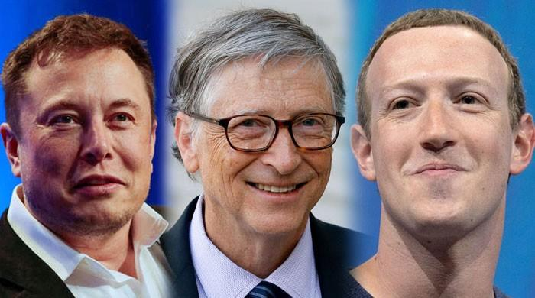

Innovation is a necessity for Indians to get global recognition in terms of the quality of their manufactured units. Instead of focusing on the caste and religious issues, If Indians can fund more on Research and Development, Innovation is not a faraway sight for them. Innovation must be a need and en element present in the DNAs to change the mindsets and turn their success path towards innovation instead of imitation. “Made in India” must not be mixed with “Imitate in India” or “Fake in India”, this should be about “Innovate in India” and “Origin in India”.



Running after Luxury is not about going for fake brands! Indian ignorant must get aware of the difference between the real brand and their fake copies, and also the side effects carried with the fake brands!